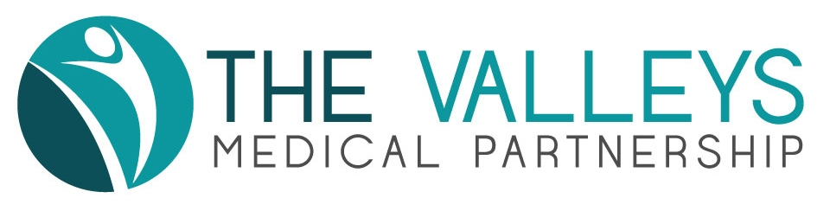
GOSFORTH VALLEY MEDICAL PRACTICE PPG

Date: Tuesday June 25th 2019

Venue: Moss Valley Medical Practice, Eckington S214BZ

1. Attendance & Apologies

Present:  Glyn Jones (Chair)  Howard Mills (Minutes)  John Hutchinson  Helen Lane  Mike Sims  Mary Milner  Wendy Jones  Jenny Mills  Shelley Hinson  Stuart Tilley (Practice Manager) | Apologies:  Sarah Bond  Ryan Bond  Pat Boyle  Jean Jackson

- Chairman's Welcome and Apologies received

Glyn Jones welcomed attenders. Apologies were noted (see above).

- Minutes of Previous Meetings

The minutes of the previous meeting on April 11th 2019 were accepted as an accurate record.

- Matters arising from previous minutes

- Communications Group

Glyn Jones updated. Matters are in hand with the Dronfield School to take an initiative in the Autumn through the 6th form Head. Mike Simms will provide Glyn Jones with similar contact at Eckington School to facilitate contact there.

Action: GJ & MS

- Practice Update

Stuart Tilley’s full report is attached. Issues of particular importance are highlighted below:

- Staffing
Charlotte Helley commenced work on June 3rd as an Assistant Practice Manager at Moss Valley. Kim Norris (Health Care Assistant) commenced on June 17th and will work across both sites.

b) GP Registrars & F2 Doctors
There has been a significant increase in the number of Registrars within the Partnership. All Partners are accredited trainers and salaried doctors are clinical supervisors. This has had a positive impact on the number of appointments offered and a reduction in waiting times.

c) Changing Secretarial Role
The secretarial role is being developed as part of the national ‘workflow optimisation’ project. This aims to upskill all secretaries and relieves the admin burden on clinicians.

5. The Role of the Pharmacist

This was deferred until the autumn meeting

6. Update on Primary Care Networks

A detailed presentation is available on the practice website. The main points are as follows:

- groups of practices in a locality will work together to deliver some local services through a Primary Care Network (PCN)
- in the future this may include social care and other community providers
- all patients will be allocated to a PCN
- if a Practice declines to join a PCN, it will have no control over the provision of services provided through the PCN
- The Valleys Medical Partnership has formed a PCN with Killamarsh, Barlborough and the Springs Medical Partnership. This covers a population of 40,000 and is wholly located in North East Derbyshire.
- the CCG has approved this arrangement
- as new services are commissioned, funding is likely to flow through the PCN
- neighbouring PCNs will work together to ensure best outcomes for patients
- no change to services will be experienced by patients in the immediate future
- a range of service will be funded through PCNs in the future, starting in 2019 with a Social Prescriber and a Pharmacist. In future years, this is likely to include Physiotherapists, Paramedics and Physician Associates)

7. Newsletter

All articles to Helen Lane by August 1st please. GJ will submit article on PPG. ST will submit article on PCN development (see 6 above). ST will submit seasonal information on pneumonia and influenza jabs, as soon as dates are known (as these dates are fixed, patients can access the service at either site, if that is more convenient).

8. Any Other Business

Next PPG Network Meeting is on July 25th 2019 (location to be confirmed)

9. Dates of PPGs for 2019

September 19th 2019 at 1830 (Gosforth Valley)
November 19th 2019 at 1830 (Moss Valley) - please note change of date from original of November 21st

hm140219

